CSE-326

PROJECT TITLE: RESTAURANT

[SYNOPSIS]

SUBMITTED TO: SUKHVIR KAUR

SUBMITTED BY: SHREYA[11900811]

A.BALAJI[11903167]

SECTION:KI9SJ

This project which covers the modules like Home,About us,Menu,Gallery,Healthy Tips,Contact us of Restaurant is based on the concept of HTML. HTML is the most commonly used language used to write web pages.It stands for Hyper Text Markup Language.

This language helps the user to create web pages and it was developed in 1989 by Tim Berners-Lee and his team.In this project a web page is created for a restaurant consisting of information like details of its menu , price of dishes ,contacting details,its going on offers and dish of the day.

Using all these details a website for a Restaurant will be created consisting of links to different web pages.

HTML is the markup language for documents designed to be displayed in a web browser.It can be assisted by technologies such as Cascading Style Sheet and scripting languages such as Javascript

Web browsers receive HTML documents from a web server or from a local storage and renders the documents into multimedia web pages.HTML describes the structure of a web page semantically and originally included cues for the appearance of the document.HTML provides a means to create structured documents by denoting structural semant ics for text such as headings,paragraphs ,links and other items.These elements are delineated by tags ,written using angle brackets.

**The basic structure of html document is:**

<HTML>

<HEAD>

<TITLE> Title of Webpage</TITLE>

</HEAD>

<BODY>

Here text which you want to show on webpage is written with the help of tags.

</BODY>

</HTML>

In this project number of tags are used out of which these three tags are the basic tags for making any html structure ;

1.<HTML>: This tag starts with <html> and ends with </html> identifies that it is a standard HTML document .Everything is written within these tags.

2<HEAD>:This tag is the HTML document header.It lies above the <body> tag and just below the <html> tag.It contains information important foa a webpage.

3.<TITLE>:This tag has to be given within the <HEAD> tag.It contains title of the document.The title should be small and include less than 64 characters.

4.<BODY>:This tag contains the text which gets displayed on the web page along with the other tags and attributes.In this tag we use formatting elements,images,heading,list,hypertextlinks to enhance the appearance of a webpage.

**Cascading Style Sheet**

Cascading Style Sheet is used to set the style in web pages which contain HTML elements.It sets the background color,font size,font-color..etc property of elements in a web pages.There are three types of CSS :

1.Inline CSS 2.Internal CSS 3.External CSS

**The basic layout of homepage that is first page of a Restaurant website:**

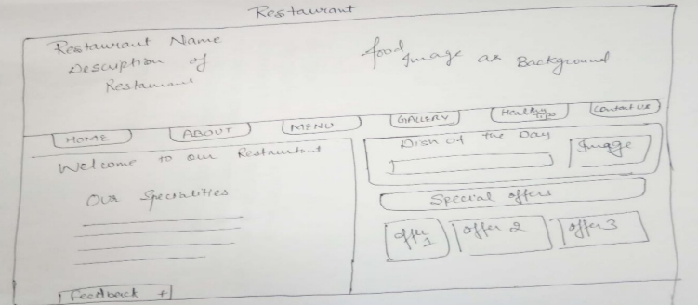

Along with these there are number of other tags which are used to make this webpage based on restaurant informations,they are-

1.<image src=filename.jpg>: This tag is used to set background of the webpage which we will display at the top of our webpage.

2.<font sixe=”14” color=”blue” face=”times new roman”>:This tag will be used for displaying the details of restaurant in an effective way by using attribute of this tag like *size,color,face*.

3.<A HREF=”link of page where to move.html”>buttons</a>:This anchor tag is used for linking the buttons like HOME,ABOUT,MENU,GALLERY,HEALTH TIPS,CONTACT US to another webpage where respective details will be provided using links .

4.<input type=button value=home>:This tag is used to create buttons for a webpage through clicking on whichone will go to new webpage.

5.<TABLE border=”0”> tag:The basic structure of this webpage is made inside the table with no table border .This table tag is a container tag with has ending tag also.All the information displayed in this webpage like background image ,home, etc are displayed using attributes of Table> tag i.e, <TR> and <TD>There ,<TR>tag is used to assign rows and <TD> tag is used to assign particular cell information.

6.<BODY BACKGROUND =”imagesrc.jpg”>:This tag is used to add background image .

**Restaurant website:**

The first step is creating restaurant website using using homepage-

1.HOME PAGE-In this page connections to other pages are made using links .As in this homepage buttons like HOME,ABOUT,MENU,GALLERY,HEALTHY TIPS and CONTACT US are linked to the respective pages providing particular information related to the pressed link.

2.BACKGROUND IMAGE-This image is used at the top of a homepage.It is the image of a restaurant whose website we are crerating.

3.RESTAURANT DETAILS-At the top restaurant basic information like its name ,and description is mentioned.like its keyfeatures including speciality about that reastaurant and its affectionating details.

4.TWO SECTION OF PAGE-In the middle 6 buttons will be used which will provide link to the other webpages .Also two sections are than made.Left side of which restaurant specialities are written ,approx. 5 to 6.Above which Welcome to our restaurant would be written. On the other hand to the right side, details based on dish of the day is mentioned along with its image is mentioned. Also special offers are shown using inbox texts along with which at the bottom three offers are mentioned in inboxes.

5.FURTHER DETAILS- Feedback is given at the bottom of webpage using <select> tag under which options are displayed using option tag.The different options given are

* EXCELLENT
* VERY GOOD
* GOOD
* WORST

Using this feedback option people will be provided with an option to rate their experience in the restaurant.

**Conclusion:**

This project is based on a webpage designing is really knowledgeable project. HTML has been used in this project to create a website based on restaurant.We have learned how to create structured and functional HTML documents-everything builts on this.To conclude with this project helps in advertising a restaurant by creating a restaurant website using HTML.Under which various types of tags are used to make the website attractive and eyecatchy while displaying all the important information about restaurant.

REFERENCES:

Websites:

* <https://developer.mozilla.org>
* <https://codetheweb.blog>
* <https://www.w3schools.com>

Books:

* HTML & CSS by Thomas A.Powell
* HTML & CSS by Julie C.Meloni
* HTML & CSS by IVANBAYROSS
* HTML & CSS by Jon Duckett